School Data Testing

Most of the integration testing fell into this category since we needed to simulate the entire process of creating parent, student, and instructor accounts and the interchange of information between them. First, a student account Sonny Smith (id 1029) was created along with a parent account Albert Smith (id 1030). Albert's account then linked to Sonny's, creating the needed parent environment to monitor student data. Then, a teacher account Walter was created. The features on this account allowed us to go the process of creating several new courses, including Chemistry, Biology, and Algebra. These registered into our Courses database table.

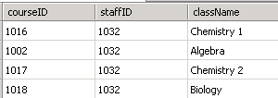
Next, Sonny was added to three classes by ID which registered into the Students database table.

Then we added a couple assignments to classes he is enrolled in and assigned him grades for them.

Assignments:
Grades:
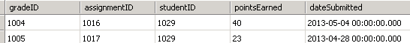
Completion of these steps then allowed us to view a list of enrolled classes from both the parent and student account. The assignment with a future due date showed up in the View Assignments page, while the other showed up in the Grades page for the appropriate class.

Enrolled classes:
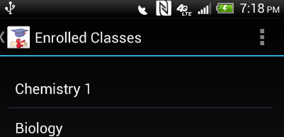

Grades:

Upcoming assignments:
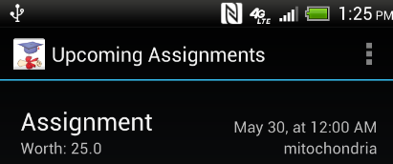

GPS Testing

Both GPS and SMS logging can be disabled upon compilation of the Android package. To test that these both ran smoothly in the scope of the entire project, they were enabled together and left to run on our phones for an extended time period. For GPS, this extension was most important to verify that the locations were taken at regular intervals defined in the code, and that the GPS receiver was re-enabled when connectivity was lost. Below is our test student's student ID and timestamps the location gathered from the time when his account was logged in.

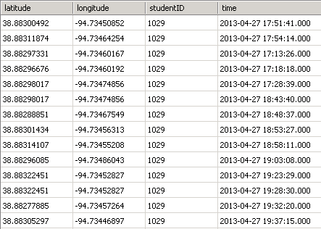
The several days that the application continued to take consistent GPS samples without any system notifications that SternerLearn had crashed is sufficient robustness testing of this feature. Viewing the Locations database table also verified that no Parent or Teacher IDs ever logged any locations.

SMS Testing

Since this feature formerly crashed while the application was idle, several texts were sent while the app was at varying states. To accomplish this, the test student account was first logged into. A free online SMS sender, http://www.textsendr.com/, was used to time our incoming texts. By inspection of the phone and the Messages database table below, its functionality was verified.

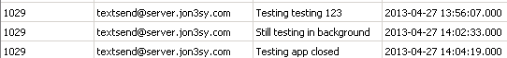
This same test process was then applied to a parent and teacher account. No texts were logged, and the application did not crash.

